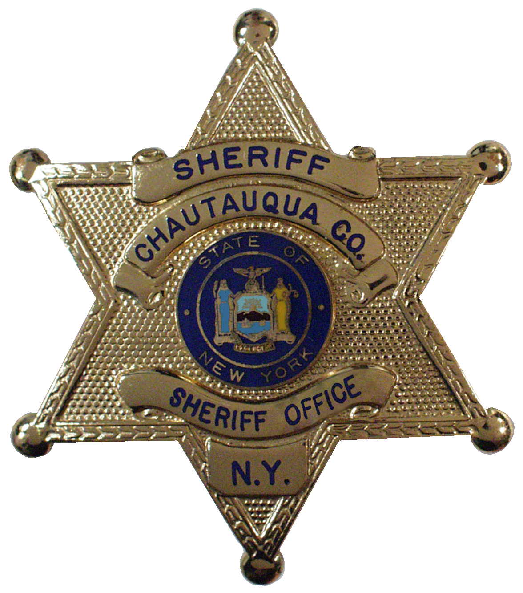
James B. Quattrone
Sheriff
Richard D. Telford
Undersheriff

OFFICE OF THE SHERIFF
Chautauqua County

Request for Transfer of Firearms License

Print Name: ___________________________________________________

Permit #: _____________________ Date Issued: ____________________

Old Address: New Address:

Street: _______________________ Street: _________________________
City/Town City/Town
Village: ______________________ Village: _______________________

Zip Code: ____________________ Zip Code: ______________________

Phone # _______________________

I hereby request the transfer of my Pistol Permit Records to
________________________________ County pursuant to Section 400.00 (Sub. 5) of the New York State Penal Law.

Signature: ________________________________ Date: __________

Complete this transfer request and return it to the Pistol Permit Office, PO Box 128 Mayville NY 14757.

Enclose a check for five dollars ($5.00).
Payable to Chautauqua County Pistol Permit

